**Acuity Knowledge Partners**

Acuity Knowledge Partners (Acuity) is a leading provider of bespoke research, data management, analytics, talent, and technology solutions to the financial services industry, including asset managers, corporate and investment banks, private equity and venture capital firms, hedge funds and consulting firms. Its global network of over 6,000 analysts and industry experts, combined with proprietary technology, supports more than 650 financial institutions and consulting companies to operate more efficiently and unlock their human capital and transforming operations. Acuity is headquartered in London and operates from 16 locations worldwide.

The company fosters a diverse, equitable and inclusive work environment, nurturing talent, regardless of race, gender, ethnicity or sexual orientation.

Acuity was established as a separate business from Moody’s Corporation in 2019, following its acquisition by Equistone Partners Europe (Equistone). In January 2023, funds advised by global private equity firm Permira acquired a majority stake in the business from Equistone, which remains invested as a minority shareholder.

For more information, visit [**www.acuitykp.com**](http://www.acuitykp.com)

|  |  |  |  |
| --- | --- | --- | --- |
| **Basic Information** | | | |
| Department | Buy-side Investment Research | Location | Pune / Bangalore / Gurgaon |
| **Organizational Relationships** | | | |
| Position reports to | Associate Director | | |
| **Job Purpose** | | | |
| **Job Description:**  We are seeking exceptionally intelligent, resourceful, and self-motivated individuals to be part of our Fundamental Credit Research team. The team resides within Investment Research and responsible for providing research and opinion related to fixed income securities globally.  The research process involves analysis of the debt instrument issuers, including financial ratio analysis, financial forecasting of issuer’s financial statements, scenario analysis, capital structure, issuer profiling, peer comparison, evaluation of fundamental credit strength and issuing credit opinion on the issuers and specific debt issues.  The individual will be part of the Fixed Income team based out of Bangalore. The team covers a wide variety of fixed income instrument issuers spanning across global, sectors and asses classes. | | | |
| **Key Responsibilities** | | | |
| The primary responsibilities include:   * Building and updating detailed credit models including KPI based projections, debt capital structure analysis, covenant analysis, distressed debt analysis and recovery analysis, * Preparing credit reports, even update, real time earnings on companies under coverage * Ability to perform Rising star and fallen angel analysis * Providing opinion and rating recommendation on the issuers * Experience in giving bond recommendation and performing relative valuation * Responsible for client interaction and managing client expectations * Experience in writing analytical reports and earnings conference call summaries * Work experience in working on HY and DD debt is desirable * Prepare and implement checklist, dashboard, quality control tools * Provides input and ideas for improvement in TAT and efficiency | | | |
| **Key Competencies** | | | |
| Core Skills Required   * MBA (Finance) with experience in building FIC models, writing initiations and real time earnings summaries. CFA and FRM is an added advantage * Excellent analytical skills, good writing & communication skills * Demonstrates a very high degree of Initiative, self-leadership, and entrepreneurship * Job requires extremely high level of attention to detail, meticulousness and accountability * Strong quantitative, analytical and interpretive skills * Abide by TAT and improve customer satisfaction over the period | | | |

***Acuity Knowledge Partners has been the proud recipient of several industry recognitions notably certified Great Places to Work in India and Costa Rica, AVTAR Best Companies for Women in India, AVTAR Most Inclusive Companies Index and Workplace Equality Index as a Silver employer.***

**Follow us on social media to stay updated with Acuity news**

**[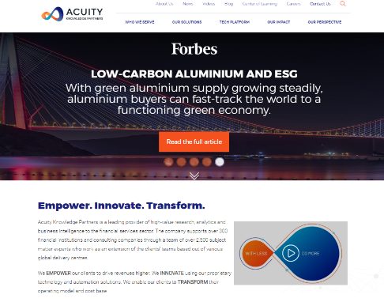](https://www.acuitykp.com/)**

**Acuity Social Media**

**LinkedIn:** <https://www.linkedin.com/company/acuity-knowledge-partners/>

**Facebook:** <https://www.facebook.com/AcuityKnowledgePartners>

**Twitter:** <https://twitter.com/AcuityKP>

**YouTube:** <https://www.youtube.com/AcuityKnowledgepartners>