**Acuity Knowledge Partners**

Acuity Knowledge Partners (Acuity) is a leading provider of bespoke research, analytics and technology solutions to the financial services sector, including asset managers, corporate and investment banks, private equity and venture capital firms, hedge funds and consulting firms. Its global network of over 6,000 analysts and industry experts, combined with proprietary technology, supports more than 500 financial institutions and consulting companies to operate more efficiently and unlock their human capital, driving revenue higher and transforming operations. Acuity is headquartered in London and operates from 10 locations worldwide.

The company fosters a diverse, equitable and inclusive work environment, nurturing talent, regardless of race, gender, ethnicity or sexual orientation.

Acuity was established as a separate business from Moody’s Corporation in 2019, following its acquisition by Equistone Partners Europe (Equistone). In January 2023, funds advised by global private equity firm Permira acquired a majority stake in the business from Equistone, which remains invested as a minority shareholder

For more information, visit [www.acuitykp.com](http://www.acuitykp.com)

|  |  |  |  |
| --- | --- | --- | --- |
| Basic Information | | | |
| Department | Buy-side Investment Research | Location | Bangalore/Pune |
| Key Responsibilities | | | |
| Workflow could include:   * Building and updating financial models with scenario analysis * Carrying-out DCF, relative, SOTP and other relevant valuation methods * Developing accurate assumptions and valuation with rationale * Screening large datasets to identify investment ideas and assisting PMs/CIOs in their investment decisions * Discussion investment ideas and stock updates with PM/CIO * Preparing earnings reviews, preview, attend con calls and management meetings * Preparing pitch notes/presentations, industry and thematic notes * Creating and updating databases * Collecting and analyzing news * Handling ad hoc research request * Maintain constant communication with the client and other stakeholders | | | |
| Key Competencies | | | |
| The analyst should have   * Excellent financial modeling and research report-writing/presentation making skills * Should have ability to think through drivers and KPIs across broad range of sectors * Good client relationship management skills and communication skills * An eye for details and ability to handle multiple workflows with tight deadlines * Numerical abilities * Building complex, error-free models with well-defined revenue/costdriver assumptions * Carrying out earnings sensitivity analysis * Providing own valuation views after carrying out relative, DCF-based or industry appropriate valuations * Writing skills * Writing in a logical and structured manner that requires minimal rework * Writing bulletins and one-page summaries * Linking macro/industry analysis to the output * Building effective presentations * Others * Collecting news; summarizing and providing analysis that adds value; and preparing charts, tables, and databases   Advantageous if has experience in using technologies: Python, SQL, Power BI, etc Good client relationship management skills and communication skills | | | |

***Acuity Knowledge Partners has been the proud recipient of several industry recognitions notably certified Great Places to Work in India and Costa Rica, AVTAR Best Companies for Women in India, AVTAR Most Inclusive Companies Index and Workplace Equality Index as a Silver employer.  To know more,*** ***click*** [***here***](https://www.acuitykp.com/awards-and-recognition/).

**Follow us on social media to stay updated with Acuity news**

**[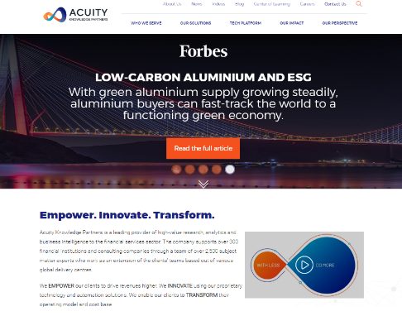](https://www.acuitykp.com/)**

**Acuity Social Media**

**LinkedIn:** <https://www.linkedin.com/company/acuity-knowledge-partners/>

**Facebook:** <https://www.facebook.com/AcuityKnowledgePartners>

**Twitter:** <https://twitter.com/AcuityKP>

**YouTube:** <https://www.youtube.com/AcuityKnowledgepartners>