**Acuity Knowledge Partners**

Acuity Knowledge Partners (Acuity) is a leading provider of bespoke research, analytics and technology solutions to the financial services sector, including asset managers, corporate and investment banks, private equity and venture capital firms, hedge funds and consulting firms. Its global network of over 6,000 analysts and industry experts, combined with proprietary technology, supports more than 500 financial institutions and consulting companies to operate more efficiently and unlock their human capital, driving revenue higher and transforming operations. Acuity is headquartered in London and operates from 10 locations worldwide.

The company fosters a diverse, equitable and inclusive work environment, nurturing talent, regardless of race, gender, ethnicity or sexual orientation.

Acuity was established as a separate business from Moody’s Corporation in 2019, following its acquisition by Equistone Partners Europe (Equistone). In January 2023, funds advised by global private equity firm Permira acquired a majority stake in the business from Equistone, which remains invested as a minority shareholder.

For more information, visit [www.acuitykp.com](http://www.acuitykp.com)

|  |  |  |  |
| --- | --- | --- | --- |
| Basic Information | | | |
| Department | Investment Research | Location | Bangalore/Gurgaon/Pune |
| Key Responsibilities | | | |
| * Building and updating financial models and carrying out valuations * Preparing earnings reviews and previews * Providing initiation of coverage support, including building models, valuation, and writing reports * Collecting and analyzing news * Handling routine periodical updates * Handling client requests * Updating/creating marketing presentations | | | |
| Key Competencies | | | |
| The analyst should have   * Excellent financial modeling and research report-writing skills * Numerical abilities * Building complex, error-free models with well-defined revenue/costdriver assumptions * Carrying out basic earnings sensitivity analysis * Providing own valuation views after carrying out both relative and DCF-based valuations * Others * Collecting news; summarizing and providing analysis that adds value; and preparing charts, tables, and databases   Good client relationship management skills and communication skills | | | |

***Acuity Knowledge Partners has been the proud recipient of several industry recognitions notably certified Great Places to Work in India and Costa Rica, AVTAR Best Companies for Women in India, AVTAR Most Inclusive Companies Index and Workplace Equality Index as a Silver employer.  To know more,*** ***click*** [***here***](https://www.acuitykp.com/awards-and-recognition/).

**Follow us on social media to stay updated with Acuity news**

**[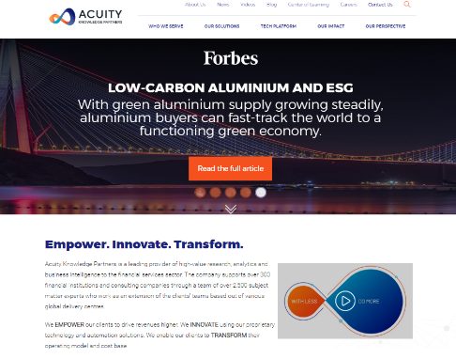](https://www.acuitykp.com/)**

**Acuity Social Media**

**LinkedIn:** <https://www.linkedin.com/company/acuity-knowledge-partners/>

**Facebook:** <https://www.facebook.com/AcuityKnowledgePartners>

**Twitter:** <https://twitter.com/AcuityKP>

**YouTube:** <https://www.youtube.com/AcuityKnowledgepartners>